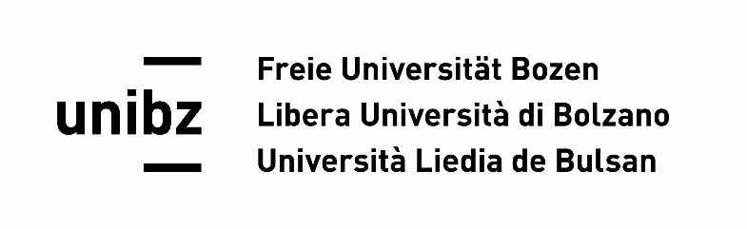

CALL FOR PAPERS

Workshop
12 - 13 June 2026

Free University of Bolzano-Bozen
Faculty of Education

Cultural Exchange and Human Development in the 21st Century:
Navigating East-West relations

This workshop explores the role of cultural exchange in shaping human development and East–West relations in the 21st century. It examines contemporary Middle Eastern contexts and their wider global interconnections through the critical lenses of postcolonial and decolonial theories, interrogating how historical power asymmetries between the West and the Middle East continue to shape cultural interactions, modes of knowledge production, development trajectories, and collective identities.
A postcolonial perspective reveals how the East–West relationship has often been structured by Orientalist discourses that portray the Middle East as dependent on Western intervention for cultural, moral, or development issues. In this framing, cultural exchange becomes a site of asymmetrical knowledge production, where the West is positioned as the source of value and the East as the recipient.
A decolonial perspective extends aspects of postcolonial theory by actively decentering Western epistemologies and foregrounding local knowledge production, agency, and institutional structures. It seeks not only to dismantle inherited power hierarchies rooted in colonial legacies but also to enable the emergence of autonomous modes of identity, self-representation, and intellectual production. In doing so, it affirms the capacity of communities in this region to define development and cultural transformation on their own terms.
Since the 1990s, the region has acquired increasing international significance, marked by growing pluralism and cosmopolitanism. Specific case studies can shed new light on its role within broader transnational and global dynamics. Rather than positioning identity and culture in opposition to westernised modernity, this perspective highlights evolving social formations and new realities, particularly in relation to migration and labour, changing gender roles and questions of justice, cultural and educational exchanges, and the social and environmental sustainability of urban growth.
In light of this approach, this workshop aims to bring together scholars working across diverse regional contexts to explore shared challenges, opportunities, and future trajectories. In particular, we seek to examine how historical and contemporary East–West relations shape power dynamics both vertically (between states and institutions) and horizontally (across social and cultural fields), as well as agency and processes of knowledge production. We therefore invite contributions engaging with, but not limited to, the following themes:

- Migration, cultural diversity, and urban governance: Exploring how postcolonial histories, national narratives, and urban policies shape mobility, identity, and belonging, and how citizens and migrants negotiate everyday forms of inclusion, exclusion, and integration.

- Education, intercultural dialogue, knowledge production, cultural exchange and human resources: Analysing how education and cultural systems reproduce or challenge global hierarchies; whose knowledge is recognised within development and policy discourses; the role of women in cross-culture and educational spheres.

- Political economy, sustainability, and global interconnections: Exploring how economic models, governance frameworks, environmental transitions, and transnational linkages shape contemporary political and economic landscapes, including debates around social justice, sustainability, and future development pathways.

The selected authors will be invited to present and discuss their work at a workshop held at the Faculty of Education, Free University of Bolzano-Bozen (Italy), on June 12–13, 2026. During the workshop, all authors will have the opportunity to share their ideas and receive feedback on their contribution. Presenting authors will also have the chance to publish an article in an edited volume with a renowned international publishing house.

Submission Guidelines:
- Abstracts and papers must be submitted in English.
- Deadline for abstracts: 1 March 2026.
- Length of abstracts: approximately 350 words.
- Abstracts must indicate which thematic cluster they align with and include at least three keywords.

Submission:
Please send your abstract along with a short CV to:
Annemarie Profanter — anprofanter@unibz.it

All submissions are peer reviewed.

International scientific committee:

Prof. Dr. Elena Maestri
Faculty of Political and Social Sciences
Department of Political Science
Università Cattolica del Sacro Cuore
Italy
mailto: elena.maestri@unicatt.it
http://dipartimenti.unicatt.it/scienze_politiche

Prof. Dr. Gennaro Errichiello
Assistant Professor
Social Development and Policy
School of Arts, Humanities and Social Sciences
Habib
University Karachi
Pakistan
mailto: gennaro.errichiello@ahss.habib.edu.pk
https://habib.edu.pk/AHSS/gennaro-errichiello/

Dr. MA Stephanie Ryan Cate Gibson
University of Alabama in Huntsville
College of Nursing, Gulf Scholars Program
USA
mailto: ryan@holisticperformancegroup.com
https://www.holisticperformancegroup.com/staff

Prof. Dr. Dr. Mag. MSc Annemarie Profanter
Libera Università di Bolzano - Freie Universität Bozen
Facoltà di Scienze della Formazione - Fakultät für Bildungswissenschaften
Italy
mailto: annemarie.profanter@unibz.it
http://www.annemarieprofanter.com/

